Erwing Augustin
IT 140
Game design
Fear the Cat lady
The ferociously lazy cat lady has taken over the master bedroom, your job as a brave adventurer is to Capture and get rid of her, but be warned she is agile and strong and dangerous with her sharp claws. You will begin at the start point in the Garage, but before you take her on; you will need to travel throughout the House gathering supplies. In the living room you will find a laser pointer, this will help in distracting the cat lady. In the bathroom you will find a spray bottle, this will help in fighting off the cat lady. In the kitchen you will find a squeaky toy, this will also help on distracting the cat lady. In the regular bathroom you find Catnip, this will be used to daze and confuse the cat lady. In the regular bedroom is a scratching post, this will help you block the cat lady’s sharp claws. In the dining room is a cat carrier, this will help in trapping the cat lady.
Here is a list of rooms and Items
Garage | Start point
Mud room | No item
Living room | Laser pointer
Dining Room | Cat Carrier
Kitchen | Squeaky Toy
Regular Bedroom | Scratching post
Regular Bathroom | Catnip
Master Bathroom | Spray bottle
Master Bedroom | Cat Lady/Boss

Game Map

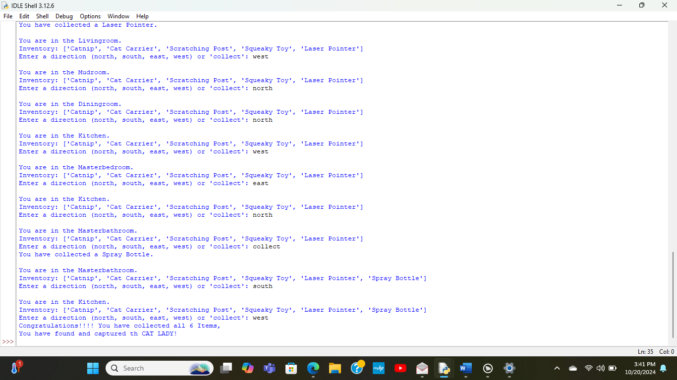
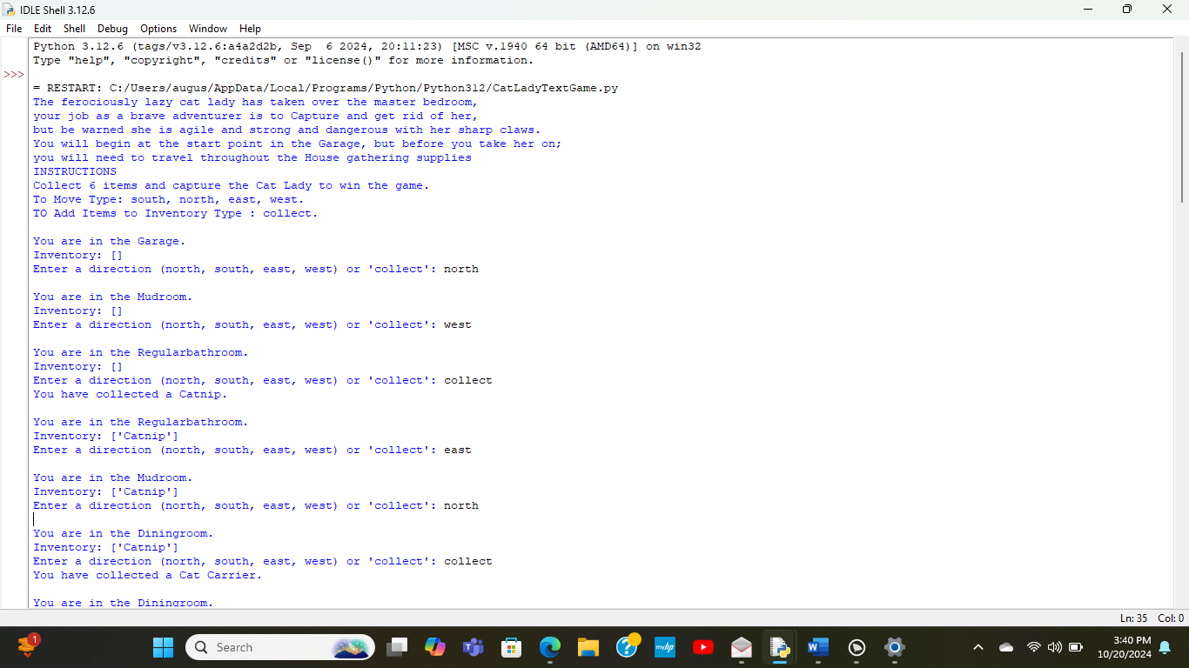
Game output
Garage
Start point
Bedroom/
Cat lady’s lair

Dinning room
Cat carrier
Living room
Laser pointer
Kitchen
Squeaky toy
Regular bedroom
Scratching post
Regular bathroom
Catnip
Mud room
Master
Bathroom
Spray bottle
East
West
South
north

Game code
#Erwing Augustin
#It 140
#CAT LADY game

# displays rules at start of game

print("The ferociously lazy cat lady has taken over the master bedroom,\nyour job as a brave adventurer is to Capture and get rid of her,\nbut be warned she is agile and strong and dangerous with her sharp claws.\nYou will begin at the start point in the Garage, but before you take her on;\nyou will need to travel throughout the House gathering supplies")
print("INSTRUCTIONS\nCollect 6 items and capture the Cat Lady to win the game.\n""To Move Type: south, north, east, west.\n""TO Add Items to Inventory Type : collect.")

# Define the rooms and their connections
rooms = {
'Garage': {'north': 'Mudroom'},
'Mudroom': {'south': 'Garage', 'north': 'Diningroom', 'east': 'Livingroom', 'west': 'Regularbathroom'},
'Diningroom': {'north': 'Kitchen', 'south': 'Mudroom'},
'Regularbathroom': {'east': 'Mudroom'},
'Livingroom': {'north': 'Regularbedroom', 'west': 'Mudroom'},
'Regularbedroom': {'south': 'Livingroom'},
'Masterbathroom': {'south': 'Kitchen'},
'Kitchen': {'south': 'Mudroom', 'north': 'Masterbathroom', 'west': 'Masterbedroom'},
'Masterbedroom': {'east': 'Kitchen'},
}
# Define the items in each room
items = {
'Diningroom': 'Cat Carrier',
'Livingroom': 'Laser Pointer',
'Regularbathroom': 'Catnip',
'Regularbedroom': 'Scratching Post',
'Kitchen': 'Squeaky Toy',
'Masterbathroom': 'Spray Bottle',
'Masterbedroom': 'Cat Lady'
}
# Function to move between rooms
def move(current_room, direction):
if direction in rooms[current_room]:
return rooms[current_room][direction]
else:
print("You can't go that way!")
return current_room

# Function to collect items
def collect_item(current_room, inventory):
if current_room in items:
item = items[current_room]
if item != 'Cat Lady':
inventory.append(item)
print(f"You have collected a {item}.")
del items[current_room] # Remove the item from the room
else:
print("the CAT Lady is here! You can't collect anything.")
else:
print("There is nothing to collect here.")
#starting Room
def main():
current_room = 'Garage'
inventory = []

while True:
print(f"\nYou are in the {current_room}.")
print("Inventory:", inventory)
command = input("Enter a direction (north, south, east, west) or 'collect': ").strip().lower()

if command in ['north', 'south', 'east', 'west']:
current_room = move(current_room, command)
elif command == 'collect':
collect_item(current_room, inventory)
else:
print("Invalid command!")

# End the game if the player finds 6 items and makes it to the Masterbedroom
if len(inventory) == 6 and current_room=='Masterbedroom':
print("Congratulations!!!! You have collected all 6 Items,\nYou have found and captured th CAT LADY!")
break

if __name__ == "__main__":
main()

